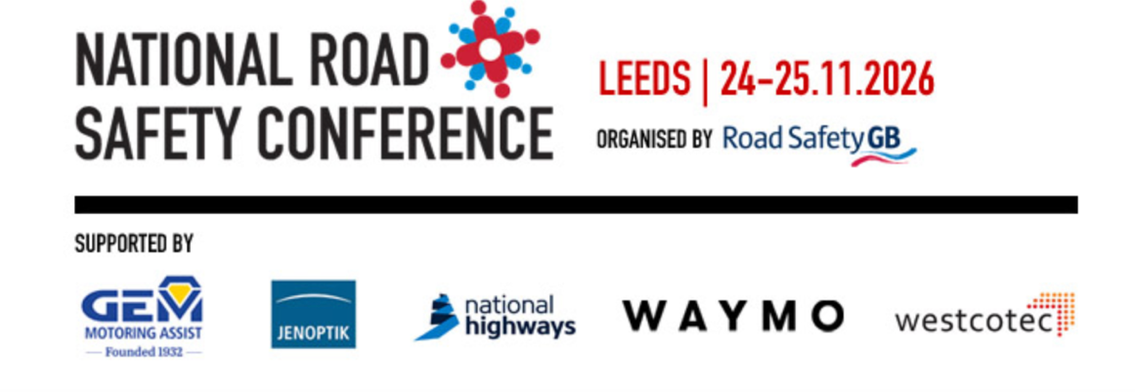
Organised by Road Safety GB/Facilitated by Stennik
Leeds – 24/25 November 2026
Event Terms & Conditions

1. General
These Terms & Conditions (“T&Cs”) apply to the National Road Safety Conference 2026 (“the Event”) organised by Road Safety GB and facilitated by Stennik (“the Organiser”). By purchasing a ticket or attending the Event, you agree to these T&Cs.

2. Tickets & Entry
- A valid registration is required for entry.
- Tickets are non-transferable unless otherwise stated.
- The Organiser reserves the right to refuse entry or remove any attendee for unreasonable or unsafe behaviour.
- Any specific dietary and access requirements should be discussed with the Organiser before booking to ensure individual needs can be met.

3. Payments, Refunds & Cancellations
- All cancellations are subject to a 20% administration fee. Cancellations are accepted up to Friday 11 September 2026 – after this date the full delegate fee will be payable, even if you are not able to attend.
- If the Event is cancelled, refunds will be issued to the original payment method.
- If the Event is rescheduled, places will automatically transfer to the new date.
- The Organiser reserves the right to change the Event programme.

4. Health, Safety & Liability
- Attendees must comply with all health & safety instructions given by staff, security, or venue personnel.
- Attendees are responsible for their own belongings. The Organiser accepts no liability for lost, stolen, or damaged items.
- The Organiser accepts no liability for personal injury unless caused by proven negligence.
- Exhibitors are required to produce a Risk Assessment, proof of Public Liability Insurance and PAT testing for all electrical equipment brought on site (including extension leads etc).

5. Prohibited Items & Behaviour
- Illegal substances, offensive weapons, and any items deemed unsafe by security are strictly prohibited.
- Anti-social, abusive, or dangerous behaviour may result in removal from the Event without refund.

6. Force Majeure
The Organiser is not liable for delays, changes, or cancellations caused by events outside its reasonable control (e.g. extreme weather, strikes, government restrictions, venue closure).

7. Photography & Media
- The Event may be photographed or recorded for promotional purposes. By attending, you consent to being included in such media unless you notify the Organiser in writing beforehand.

8. Data Protection
- Attendee information will be collected and used only for the purposes of administering the Event and in accordance with relevant data protection laws.

9. Governing Law
These T&Cs shall be governed by and construed in accordance with the laws of [England & Wales / Scotland / Northern Ireland].

